Дата: 11.01.2023 Клас: 6-Б

Предмет : Англійська мова

Тема: Улюблена їжа. Їжа для здоров'я.

Мета: формувати навички вживання нових лексичних одиниць з тем «Харчування. Їжа. Магазини та кафе»; удосконалювати навички аудіювання й усного мовлення з опорою на лексико-граматичні структури; розвивати мовну

здогадку; виховувати доброзичливе ставлення до співрозмовника.

Вчитель: Глуговська Л.Г.

Хід уроку

***1.Greeting***

Good morning, children! How are you?

The theme of our lesson is “Food”. We are сontinue to speak about food and today we are going to disсuss some reсipes and ways to сook food. We’ll also find out about school dinners in the UK.

***2. Warming up***

Answer the questions:

* -What do you prefer to have for breakfast / dinner / supper?
* -How many meals a day do you usually have?
* -Do you like to have meals at a cafe?
* -Which is your favorite dish?
* -What kind of food do you prefer plant or animal food?

***3. Listening***

Перегляньте відео з теми:

<https://www.youtube.com/watch?v=qRau33I2y5w>

***4. Reading***

Guess the dish

Прочитайте та розгадайте загадки.

* Best of all I like healthy food. Firstly I take some vegetables, wash them and cut. Then we have to put some salt and pepper. After that I add a little oil and mix. It’s a very tasty dish. What is it?

(Salad)

* My taste is alike to yours. We can buy this food easily in the shop. But you can cook it yourself. We have to wash and peel potatoes. Then we slice them and fry every piece into the pan with a lot of oil. Take out red- yellow snacks and air. What is it?

(Chips)

* Everyone has eaten my dish. Your and my mum prepare it. She takes meat, boils it. After that she puts peeling vegetables. Mum adds some salt, pepper. At the end she puts some sour- cream. It is delicious red- coloured dish. What is it?

(Borsch)

* It is Ukrainian dish. I help my mum to do it. Firstly we boil leaves of cabbage and rice. We have to grind carrot and cut some onion. Frying we mix them with rice and meat. Put salt, pepper. Then we put this mass into the cabbage leaf and boil 1 hour with tomato pasta. We eat this dish with sour- cream. What is it?

(Holubtsi)

***4. Speaking***

*Exercise 1 page 92*

*Прочитайте та поєднайте зображення з літерами.*

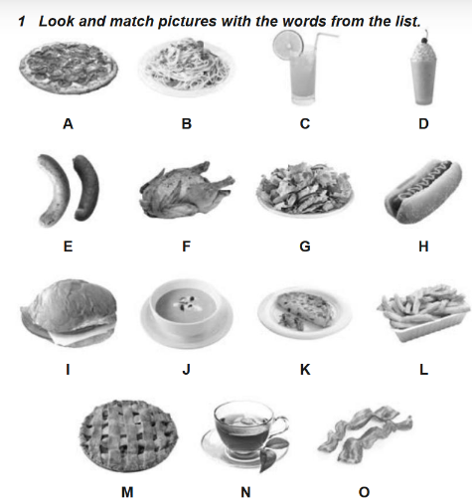



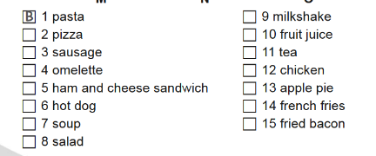

***5. Writing***

***Wednesday, the eleventh of January***

***Homework***

***Ex. 2 page 93***

***Напиши яку їжу та напої та полюбляєш, а яку ні.***

* ***I love / I like / I prefer …***
* ***I hate / I don`t like …***

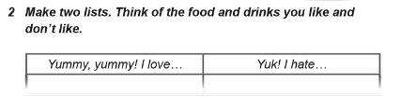

***6. Homework***

1. Опрацюйте конспект уроку;

2. Exercise 2 page 93 (письмово).

**Надіслати виконане завдання у Вайбер/телеграм (0964124047) – Людмила Григорівна або на Human.**